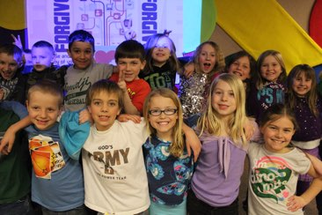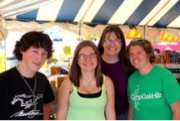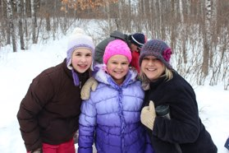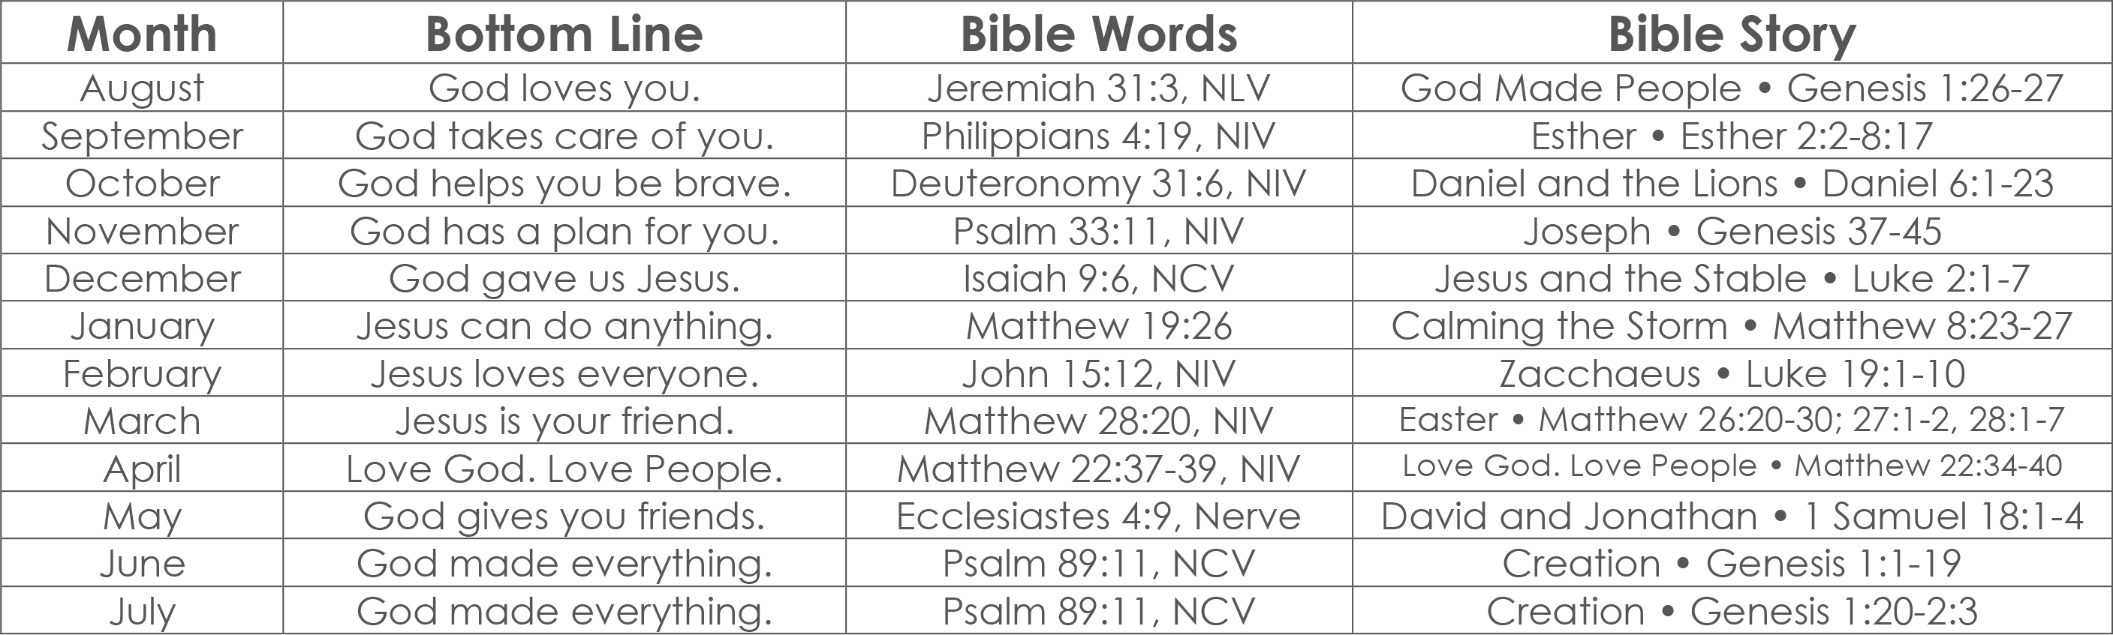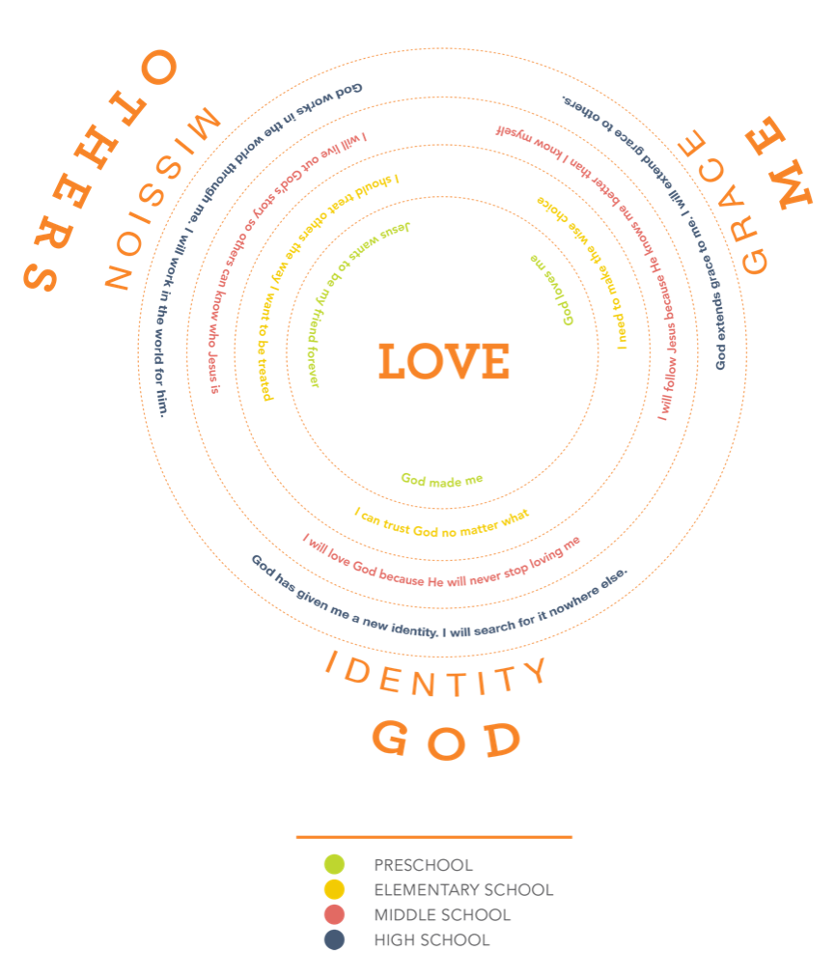

TIME MATTERS

Time is precious and we have so little of it so let’s…

**Make Time for What’s Important.**

**Faith**. We make no apologies for encouraging families to make time in their weekly schedule for church and conversations about faith.

**Family**. We know the family calendar can get a little crazy with work, school, and everyone’s sports and activities. The church doesn’t need to add to the chaos by pulling the family apart at different times of the week. So, we try to protect the family calendar by scheduling our ministries at the same time as much as possible–Sunday mornings and Wednesday nights.

**Friendship**. We believe that God designed us to be in community with others. We’re also convinced that life change happens best in the context of relationships. We can plan the best program in town but if kids don’t have real faith building relationships with other kids and adult leaders, if they don’t experience real community, then all that planning is a waste of time. That’s why we make time for small groups. You see, the small group is the big event. So, we’re asking you to make time for your small group

THE SMALL GROUP IS THE BIG EVENT

Be informed. Be prepared. Be connected.

Check your Facebook Group or email every Thursday for next week’s plan.

Study the text and think of how it applies to your kids.

Text your kids during the week.

**Make the Best of the Time We Have.**

As a church, we only have about 40 hours a year to influence kids compared to the approximately 3000 hours a year that parents have. So, first of all that reminds us that parents have the primary spiritual influence in a child’s life and our job is to support them. This is why we talk so much about Partnering with Parents.

Second, when we stop to count the hours we have, we make the hours we have count. That’s why we put so much energy into our weekly experiences and work so hard to craft every minute of our time together.

TIME

WORDS

“‘Love the Lord your God with all your heart and with all your soul and with all your strength and with all your mind’ and, ‘Love your neighbor as yourself.’” - Jesus, Luke 10:27

2015-2016

kids

students

young

adults

Leader’s Handbook

marriage

& family

Small Group Leader

As a Small Group Leader, you have the opportunity to deeply influence the life and future of a kid and his understanding of and relationship with Jesus.

Becoming a volunteer is easy. Becoming a Small Group Leader requires some time and energy. Your kids have great potential to be leaders and world changers in the Kingdom of God. And, God has called you into one of the most influential roles in their lives.

This handbook will guide you through the 6 things that every kids needs over time and and that will help you lead your few.

WORDS MATTER

The right words over time help keep kids moving in the right direction.

**GOD’S WORD HAS POWER.**

Every lesson has it’s roots in Scripture. Every small group discussion seeks to apply the Word to life. For every issue/topic we ask one of two questions that date back to the beginning of the Covenant Church, *“Where is it written?”*

**Know the Word.** Study the week’s biblical text. Know the story well enough to tell it and talk about it.

**Be in the Word Together.** During every small group make sure each kid has a bible in front of them and has it open to the text or story you’re discussing.

**Explain the Word.** Kids will look to you for explanations of what words in Scripture mean and what the Scripture is saying. Be ready to do your best to explain what you know but don’t be afraid to say “I don’t know.” Just make sure you follow up on it with them.

**Repeat the Word.** Whenever there is a key verse for the lesson, repeat it as often as you can. Have kids repeat it, as well, encouraging them to memorize it.

**OUR WORDS HAVE INFLUENCE.**

What we say and how we say it can change the course of a kid’s life. We need to be intentional about what we say, why we say it, and how it impacts kids.

**Be Gracious with Your Words.**Encourage kids toward what is good and what is right before you critique them for what is wrong and what is bad.

**Repeat the Bottom Line.** Each week’s lesson has one bottom line. Be sure to repeat it in your discussions and discuss with kids how it applies to their lives.

**Repeat the BIG IDEAS.** We have several big ideas that we repeat in all our teachings. Please learn them, memorize them, and repeat them as often as you can in discussions, making natural connections to life situations.

It all starts with …

“‘Love the Lord your God with all your heart and with all your soul and with all your strength and with all your mind’ and, ‘Love your neighbor as yourself.’” - Jesus, Luke 10:27

WORDS



2

Set Up the SGL

We want small group leaders to be the ones who help students apply the truth to their lives. Why? Because life change happens best in the context of relationships. So, we want the application to really come alive in small group discussions. How do you do that?

**THE TEASER GETS THEM THINKING.** Explore possibilities of life application but don’t give them the application points. It’s the small group leaders’ job to help kids apply the truth to their lives.

Think football. Your job is to get it to the 10 yard line and let the small group leader make the touch down! Or, think basketball. Your job is to bring the ball up the court, give it to the small group leader and let them score the winning shot!

WORDS

PRESCHOOL

The love and care you provide as nursery and preschool leaders gives infants and preschoolers their first impressions of our loving God. The lessons we teach from Orange: FirstLook incite WONDER about God and his Creation and are based on these three simple, but powerful, truths.

**God Made Me**

“For you created my inmost being; you knit me together in my mother’s womb. I 2 praise you because I am fearfully and wonderfully made; your works are wonderful, I know that full well.” - Psalm 139:13-14

**God Loves Me**

“For I am convinced that neither death nor life, neither angels nor demons, neither the present nor the future, nor any powers, neither height nor depth, nor anything else in all creation, will be able to separate us from the love of God that is in Christ Jesus our Lord.” - Romans 8:38-39

**Jesus Wants to Be My Friend Forever**

“For God so loved the world that he gave his one and only Son, that whoever believes in him shall not perish but have eternal life.” - John 3:16

Each month, we focus on one Bible Story, One Memory Verse, and one Bottom Line.

WORDS

ELEMENTARY

The lessons we teach from Orange: 252Basics provoke DISCOVERY of who God is and what he’s doing in the heart of each child. And, we want every kid to know and understand these three basic, but powerful, truths modeled by Jesus Luke 2:52 “Jesus grew in wisdom and stature, and in favor with God and men.”

**FAITH: I can trust God no matter what.**

Encourage kids toward what is good and what is right before you critique them for what is wrong and what is bad.

* + - * + trust and follow Jesus.
        + spend time getting to know God.
        + do whatever God says.
        + discover God’s plan for my life.

**WISDOM: I need to make the right choice.**

Encourage kids toward what is good and what is right before you critique them for what is wrong and what is bad.

* + - * + He is my Creator.
        + He is my Father.
        + He is my Guide.
        + He is my Savior.

**FRIENDSHIP: I should treat others the way   
I want to be treated.**

Encourage kids toward what is good and what is right before you critique them for what is wrong and what is bad.

* + - * + Show God’s love to those around me
        + Care enough to put others before me
        + Respect whoever God puts over me
        + Be the right friend to those beside me

So I will

Because

So I will

WORDS

MIDDLE SCHOOL

The lessons we teach from Orange: XP3MS combined with our own custom curriculum continue to provoke DISCOVERY and begin to inspire PASSION for loving God and loving others. The three basic truths for middle school are. In this phase our lessons are designed to help students begin to take ownership of their own faith, turning truths into commitments.

**I will love God because He will never stop loving me.**

Encourage kids toward what is good and what is right before you critique them for what is wrong and what is bad.

**I will follow Jesus because He knows me better than I know myself.**

Encourage kids toward what is good and what is right before you critique them for what is wrong and what is bad.

**I will live out God’s story so others can know who Jesus is.**

Encourage kids toward what is good and what is right before you critique them for what is wrong and what is bad.

WORDS

HIGH SCHOOL

In high school, like middle school, we use a combination of our own custom curriculum and Orange XP3HS. During the high school years we seek to fuel more PASSION for loving God and loving others. Then, when our kids are all grown up and are ready to graduate high school and move on into college and young adulthood, we want them to have fully experienced the WONDER of God’s **GRACE**, the DISCOVERY of their true **IDENTITY** in Christ, and the PASSION that follows a life lived out of service to God’s **MISSION**.

**GRACE  
God extends grace to me. So, I will extend grace to others.**Another way of saying this could be “We live in grace and we give grace.” Or, “Embrace Grace. Give Grace.” The end goal here is for our kids to fully embrace the grace that God has given them and to then, in turn, give grace to everyone around them.

**IDENTITY  
God has given me a new identity. I will search for it nowhere else.**  
Another way of say this could be, “We find our identity in Christ and nothing else.” A complementary phrase could be “Only God can define who you are.” The end goal here is for our kids to live their lives based on their identity in Christ and not on some identity they find in the world.

**MISSION  
God works in the world through me. I will work in the world for him.**  
A complementary phrase could be “God works in me and through me.” The end goal here is for our kids to recognize that healing in the world comes from God through his people. As reconcilers and ambassadors of Christ, our role is to be the hands and feet of Jesus in the broken and hurting world around us.

Small Group Leader

As a Small Group Leader, you have the opportunity to deeply influence the life and future of a kid and his understanding of and relationship with Jesus.

Becoming a volunteer is easy. Becoming a Small Group Leader requires some time and energy. Your kids have great potential to be leaders and world changers in the Kingdom of God. And, God has called you into one of the most influential roles in their lives.

This handbook will guide you through the 6 things that every kid needs over time and that will help you lead your few.

WORDS

WORDS MATTER

The right words over time help keep kids moving in the right direction.

**GOD’S WORD HAS POWER.**

Every lesson has it’s roots in Scripture. Every small group discussion seeks to apply the Word to life. For every issue/topic we ask one of two questions that date back to the beginning of the Covenant Church, *“Where is it written?”*

**Know the Word.** Study the week’s biblical text. Know the story well enough to tell it and talk about it.

**Be in the Word Together.** During every small group make sure each kid has a bible in front of them and has it open to the text or story you’re discussing.

**Explain the Word.** Kids will look to you for explanations of what words in Scripture mean and what the Scripture is saying. Be ready to do your best to explain what you know but don’t be afraid to say “I don’t know.” Just make sure you follow up on it with them.

**Repeat the Word.** Whenever there is a key verse for the lesson, repeat it as often as you can. Have kids repeat it, as well, encouraging them to memorize it.

**OUR WORDS HAVE INFLUENCE.**

What we say and how we say it can change the course of a kid’s life. We need to be intentional about what we say, why we say it, and how it impacts kids.

**Be Gracious with Your Words.** Encourage kids toward what is good and what is right before you critique them for what is wrong and what is bad.

**Repeat the Bottom Line.** Each week’s lesson has one bottom line. Be sure to repeat it in your discussions and discuss with kids how it applies to their lives.

**Repeat the BIG IDEAS.** We have several big ideas that we repeat in all our teachings. Please learn them, memorize them, and repeat them as often as you can in discussions, making natural connections to life situations.

It all starts with …

“‘Love the Lord your God with all your heart and with all your soul and with all your strength and with all your mind’ and, ‘Love your neighbor as yourself.’” - Jesus, Luke 10:27



WORDS

PRESCHOOL

The love and care you provide as nursery and preschool leaders gives infants and preschoolers their first impressions of our loving God. The lessons we teach from Orange: FirstLook incite WONDER about God and his Creation and are based on these three simple, but powerful, truths.

**God Made Me**

“For you created my inmost being; you knit me together in my mother’s womb. I 2 praise you because I am fearfully and wonderfully made; your works are wonderful, I know that full well.” - Psalm 139:13-14

**God Loves Me**

“For I am convinced that neither death nor life, neither angels nor demons, neither the present nor the future, nor any powers, neither height nor depth, nor anything else in all creation, will be able to separate us from the love of God that is in Christ Jesus our Lord.” - Romans 8:38-39

**Jesus Wants to Be My Friend Forever**

“For God so loved the world that he gave his one and only Son, that whoever believes in him shall not perish but have eternal life.” - John 3:16

Each month, we focus on one Bible Story, One Memory Verse, and one Bottom Line.



WORDS

ELEMENTARY

The lessons we teach from Orange: 252Basics provoke DISCOVERY of who God is and what he’s doing in the heart of each child. And, we want every kid to know and understand these three basic, but powerful, truths modeled by Jesus Luke 2:52 “Jesus grew in wisdom and stature, and in favor with God and men.”

**FAITH: I can trust God no matter what.**

Encourage kids toward what is good and what is right before you critique them for what is wrong and what is bad.

* + - * + trust and follow Jesus.
        + spend time getting to know God.
        + do whatever God says.
        + discover God’s plan for my life.

**WISDOM: I need to make the right choice.**

Encourage kids toward what is good and what is right before you critique them for what is wrong and what is bad.

* + - * + He is my Creator.
        + He is my Father.
        + He is my Guide.
        + He is my Savior.

**FRIENDSHIP: I should treat others the way   
I want to be treated.**

Encourage kids toward what is good and what is right before you critique them for what is wrong and what is bad.

* + - * + Show God’s love to those around me
        + Care enough to put others before me
        + Respect whoever God puts over me

Be the right friend to those beside me

So I will

Because

So I will



WORDS

MIDDLE SCHOOL

The lessons we teach from Orange: XP3MS combined with our own custom curriculum continue to provoke DISCOVERY and begin to inspire PASSION for loving God and loving others. The three basic truths for middle school are. In this phase our lessons are designed to help students begin to take ownership of their own faith, turning truths into commitments.

**I will love God because He will never stop loving me.**

Encourage kids toward what is good and what is right before you critique them for what is wrong and what is bad.

**I will follow Jesus because He knows me better than I know myself.**

Encourage kids toward what is good and what is right before you critique them for what is wrong and what is bad.

**I will live out God’s story so others can know who Jesus is.**

Encourage kids toward what is good and what is right before you critique them for what is wrong and what is bad.



WORDS

HIGH SCHOOL

In high school, like middle school, we use a combination of our own custom curriculum and Orange XP3HS. During the high school years we seek to fuel more PASSION for loving God and loving others. Then, when our kids are all grown up and are ready to graduate high school and move on into college and young adulthood, we want them to have fully experienced the WONDER of God’s **GRACE**, the DISCOVERY of their true **IDENTITY** in Christ, and the PASSION that follows a life lived out of service to God’s **MISSION**.

**GRACE  
God extends grace to me. So, I will extend grace to others.**Another way of saying this could be “We live in grace and we give grace.” Or, “Embrace Grace. Give Grace.” The end goal here is for our kids to fully embrace the grace that God has given them and to then, in turn, give grace to everyone around them.

**IDENTITY  
God has given me a new identity. I will search for it nowhere else.**  
Another way of say this could be, “We find our identity in Christ and nothing else.” A complementary phrase could be “Only God can define who you are.” The end goal here is for our kids to live their lives based on their identity in Christ and not on some identity they find in the world.

**MISSION  
God works in the world through me. I will work in the world for him.**  
A complementary phrase could be “God works in me and through me.” The end goal here is for our kids to recognize that healing in the world comes from God through his people. As reconcilers and ambassadors of Christ, our role is to be the hands and feet of Jesus in the broken and hurting world around us.



WORDS

“‘Love the Lord your God with all your heart and with all your soul and with all your strength and with all your mind’ and, ‘Love your neighbor as yourself.’” - Jesus, Luke 10:27

TIME

TIME MATTERS

Time is precious and we have so little of it so let’s…

**Make Time for What’s Important.**

**Faith**. We make no apologies for encouraging families to make time in their weekly schedule for church and conversations about faith.

**Family**. We know the family calendar can get a little crazy with work, school, and everyone’s sports and activities. The church doesn’t need to add to the chaos by pulling the family apart at different times of the week. So, we try to protect the family calendar by scheduling our ministries at the same time as much as possible–Sunday mornings and Wednesday nights.

**Friendship**. We believe that God designed us to be in community with others. We’re also convinced that life change happens best in the context of relationships. We can plan the best program in town but if kids don’t have real faith building relationships with other kids and adult leaders, if they don’t experience real community, then all that planning is a waste of time. That’s why we make time for small groups. You see, the small group is the big event. So, we’re asking you to make time for your small group

THE SMALL GROUP IS THE BIG EVENT

Be informed. Be prepared. Be connected.

Check your Facebook Group or email every Thursday for next week’s plan.

Study the text and think of how it applies to your kids.

Text your kids during the week.

**Make the Best of the Time We Have.**

As a church, we only have about 40 hours a year to influence kids compared to the approximately 3000 hours a year that parents have. So, first of all that reminds us that parents have the primary spiritual influence in a child’s life and our job is to support them. This is why we talk so much about Partnering with Parents.

Second, when we stop to count the hours we have, we make the hours we have count. That’s why we put so much energy into our weekly experiences and work so hard to craft every minute of our time together.

TIME

Take a look at our weekly schedules here. Take special note of the times we ask our leaders to be in their places.

**SUNDAY SCHOOL**

08:45 - Leader in Room

08:45 - Check in begins

09:00 - Small Group

09:10 - Large Group Worship

09:30 - Large Group Teaching

Preschool dismissed

09:40 - Small Group

10:00 - Kids start checking out

10:15 - Check out closes

**NURSERY**

08:45 - Leaders in Room

10:15 - Leaders leave

**KIDS CHURCH**

11:10 - Kids Released

11:13 - Leader leads Kids to Rooms

11:15 - Opening

11:20 - Story/Teaching

11:40 - Small Groups

11:50 - Check out Begins

12:05 - Check out Ends

**NURSERY**

10:30 - Leaders in Room

12:15 - Leaders leave

**COVENANT KIDS**

5:40 - Leader in room

5:45 - Check in begins

6:00 - Small Group

6:10 - Large Group Worship

6:30 - 3rd-5th Teaching / K-2nd Gym

6:50 - 3rd-5th Gym / K-2nd Teaching

7:10 - Small Group

7:30 - Check out begins

7:45 - Check out end

**SUNDAY SCHOOL  
CONFIRMATION**

08:45 Leader in Room

09:00 Class Starts

10:00 Class Ends

**FUEL**

6:00 - Leaders in Sanctuary

6:00 - Doors Open

6:15 - Large Group

6:45 - Teaching

7:00 - Small Groups

7:30 - Middle School Ends

7:45 - High School Ends

TIME

Kids

Nursery

Students

**Respect Each Other’s Time**

As we gather people for our worship services, programs, and meetings, scheduling can get complicated. We’re trying to coordinate time for hundreds of people and we need to respect everyone’s time. So it’s very important for us ALL to…

BE ON TIME.

We are committed to BEGINNING and ENDING our services and programs at the times we state. If that’s going to happen, everyone on the team needs to be in their places at their scheduled times. We ask all our leaders to be in place 15 minutes before the stated beginning time of the program or service.

We ask that all our leaders end their small groups by their stated times. This means you’ll have to plan your activities and/or discussions to transition into prayer with plenty of time to end the prayer before the stated ending time.

We also ask all our communicators to plan their lessons and messages according to the allotted times so that small groups can have maintain their allotted times, as well.

EVERY TIME

There are definitely times when life gets a little crazy and off schedule. That’s okay, we understand. If you’re running late, please call or text ahead to make arrangements. If you work with …

inform the Kids Director and another adult nursery leader.

inform the Kids Director and another group leader in your grade.

inform Students Director, your Team Leader (MS, JV, VS), and another group leader in your grade.

However, there’s a saying “if you’re always late, then you can be always on time.” Please make whatever arrangements you need to make, to be on time, every time.

TRIBES

To help kids connect better with the we need to…

The Church

Tribes Matter.

Tribes over time show us how we belong. And we all long to belong because people need people. That’s how God designed us.

As a small group leader, you have the opportunity   
to connect kids to two primary tribes.

The Church The Family

**Keep it Small**

Because we believe the small group is the big event, we’re constantly working to keep the small group … well … small. Our goal is to have groups of 5 - 8 kids in attendance per small group leader. Now that might mean that you’ll have 12 kids on your list but if you start having 10 kids or more on a regular basis, your group dynamics will begin to change and it’ll become harder to keep kids feeling like they belong. However, be careful that you don’t slip into the mindset that the kids who show up every week is your small group and the others on your lists are guests or infrequent visitors. They’re just as much a part of your small group as the others are, no matter how often they come.

**Keep it Long Term**

Our approach to discipleship is an adoptive one. We ask all our small group leaders to commit leading their small group of kids for as many years as they can. While some will discover after only one year that this gig isn’t for them, others have remained their small group’s leader for 5 or 6 years and even more as they keep in touch with their kids after graduation and on into college. The benefits of keeping it long term come when leaders can see the fruits of their investment over the course of time.

TRIBES

To stay connected to we are asking you to …

The Family

**Keep it Intergenerational**

Research shows that in order for kids to develop a healthy faith as adults, they need to heave signifiant relationships healthy adults of faith. In order to keep kids engaged with the adult church community when they become adults, we have to engage kids with the adult church community while they are kids. That’s why we get so many adults involved with our kids and student ministries. That’s we we connect them with mentors as 9th graders. And, that’s why you see so many kids involved with our worship services and ministries (on stage, at the doors, in the classrooms, in the kitchen). But they need your help to get connected. Encourage them to …

… volunteer

… get involved

… join a team

**PARTNER WITH PARENTS**

CUE THE PARENT

We’ll provide you with every kids’ parental email addresses. Set it up as a group in your email…call it your Small Group Parents. Then, when you check your Facebook Group or email every Thursday to find out next week’s plan, you’ll also find a Parent CUE paragraph that you can copy and paste into an email to send to your Small Group Parents. You can also add your own notes, as well. We’ll write it up but we want it to come from you to the parent. If it comes from us, only about 30% of parents will read it. If it comes from you, almost all of them will read it.

HONOR THE PARENT

Maintain an attitude of respect for your kids’ parents. Even if you disagree with how they handle things. Never use their relational tension for your relational gain.

SUPPORT THE FAMILY

Pay attention to their family’s calendar and checkbook. Do your best to not plan a group activity that conflicts with the family calendar nor breaks the bank.

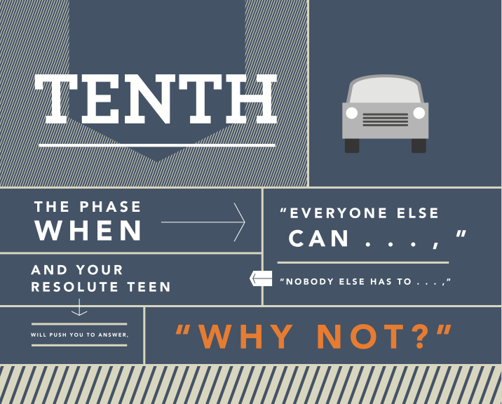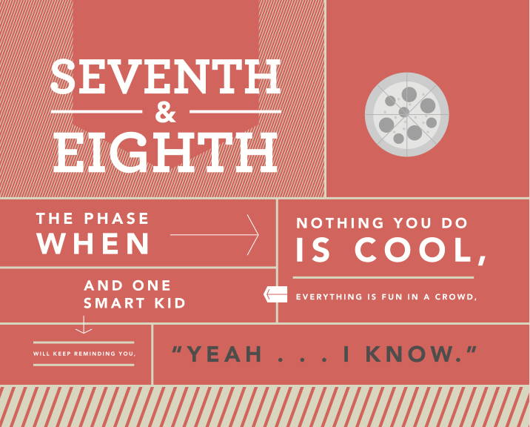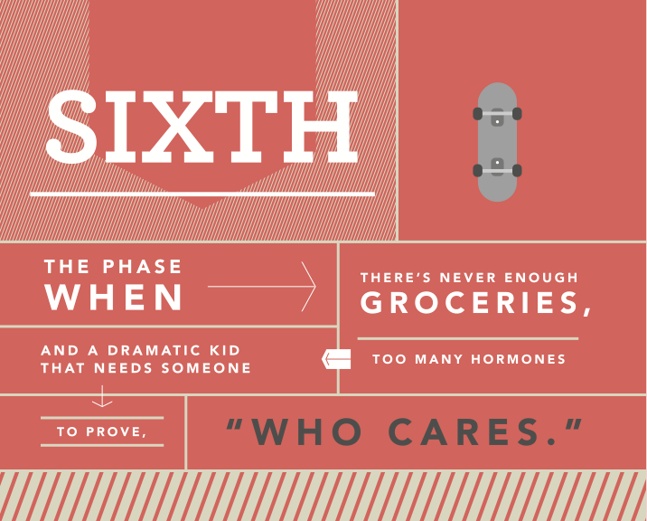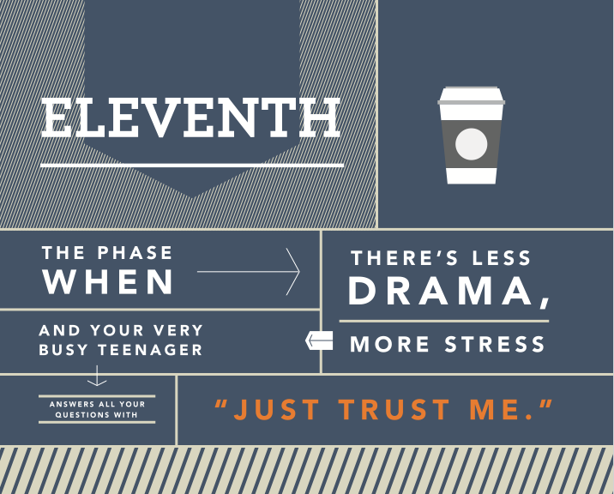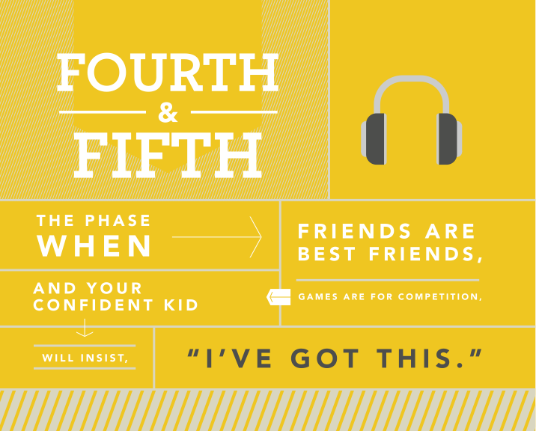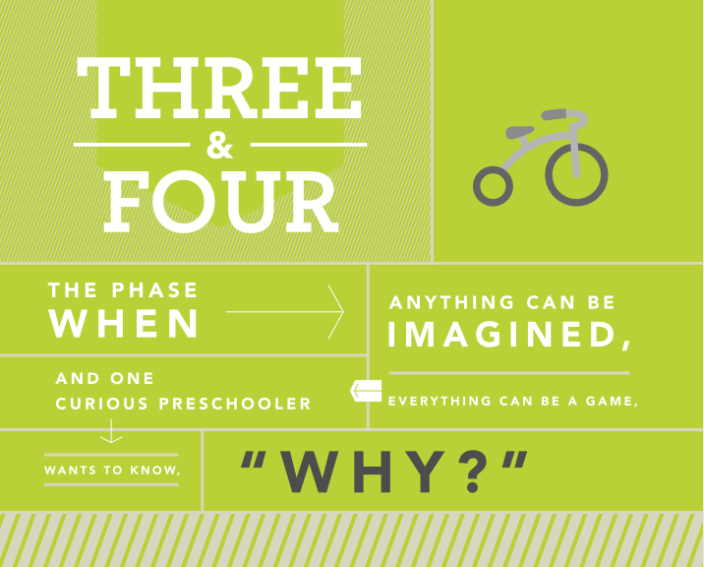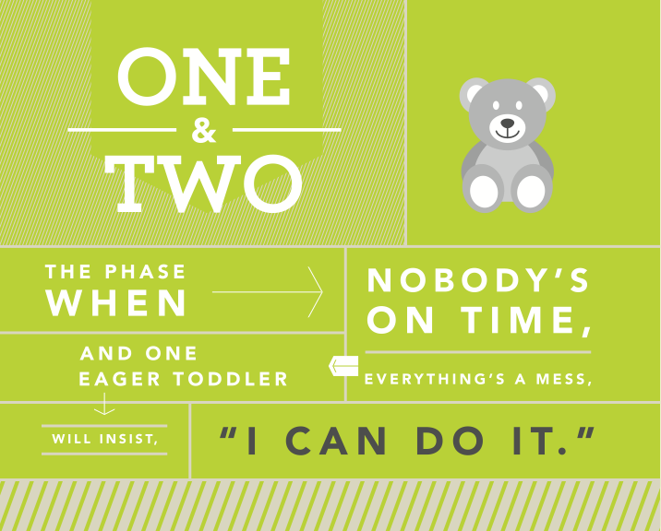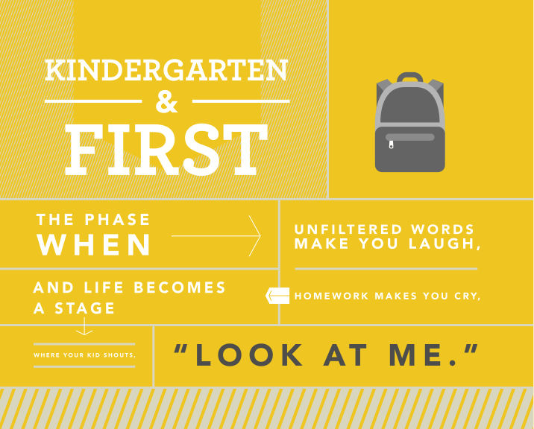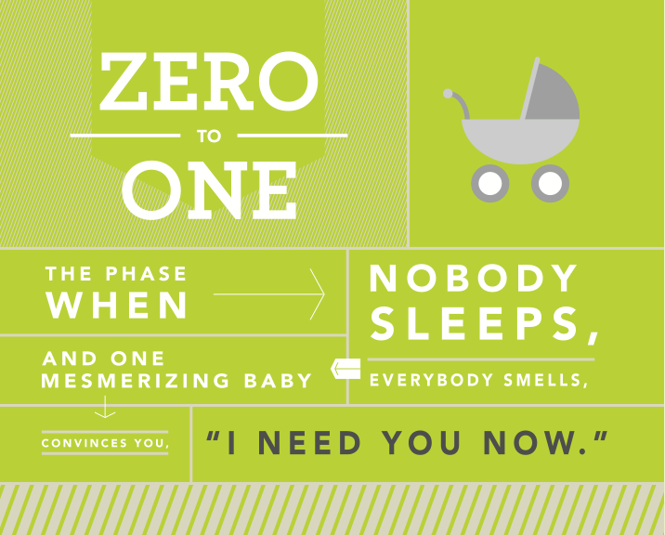

**Find out more**

**about their**

Love

LOVE MATTERS.

Love over time helps kids establish a healthy sense of worth. The way we love kids while they’re still kids will dramatically affect who they become as adults. So, first, we are asking you to prove your love by …

**Knowing Them**

If you’re going to love kids. If you’re going to prove your love for your kids. You have to know them. Really know them.

**… family life**

**… school life**

**… social life**

**… emotional life**

**… spiritual life**

It’s also important to know where they are developmentally. In other words, what PHASE they are in.

Explore your kids’ phase

in the PHASE Section.

EMPOWER

ENCOURAGE

ENGAGE

EMBRACE

LOVE

You might have noticed by now that our mission statements are Embracing & Engaging Kids, Encouraging Students, and Empowering Young Adults in their Journey with Jesus. These words all relate to every phase’s needs.

preschoolers physically. It gives a first impression of a heavenly Father

the interests and curiosities of children. It provokes knowing God personally.

students by AFFIRMING a middle schooler’s identity. It gives them a safe place to process doubts and questions.

students by MOBILIZING a high schooler’s potential. It develops a personal vision for their future.

young adults to live life and be the church the way God intended for them.

For more helpful information about the phases of a kids life, explore the PHASES Section.

Second, we are asking you to prove your love by …

**Guiding Them**

Many of our kids have grown up in the church. Many others, however, have only recently come to know Jesus. Our kids and students are at various points in their spiritual Journey, Your role is to guide them on to whatever the next step is for their journey.

The other of the two questions dating back to the beginning of the Covenant Church is “How's your walk with Jesus?” We like to explain it like this.

As we all walk along in our spiritual journey, God desires, first, that we move from simply attending church to seeking and finding a sense of true BELONGING to Christ and to the Church community; second, that we begin PURSUING life in Christ, knowledge of the Word, and service in the Kingdom; third, to become one who is PRACTICING spiritual habits, healthy relationships, and wise decision making; and, fourth, to become one who is ministry-minded, CONTRIBUTING to the ministry of the Covenant Church and God’s mission in the world.

Love

CONTRIBUTING

To the Covenant Community by taking ownership in the ministry of the church, exercising my spiritual giftedness, and encouraging others in their faith.

To the World by living as a compassionate servant to others, being a positive witness for Christ, influencing culture for the Kingdom, and fulfilling my duty as a good citizen.

PRACTICING

The Spiritual Habits of prayer, personal Bible study, reflection on the Word, and healthy living.

Healthy Relationships that honor God and edify (build up) one another.

Wise Decision Making that reflects the will of God and biblical morality, and that exercises good discernment skills.

BELONGING

To Jesus by surrendering ourselves to him in redemption relationship.

To the Covenant Community by joining in worship on Sundays, joining a small group, finding a soul friend and exploring membership.

PURSUING

Life in Christ by understanding my identity in Christ, what it means to be set apart for Christ, and working toward unity around Christ.

Knowledge of the Word by learning God’s story, embracing His central truths, and applying them to everyday living.

Service in the Kingdom by giving of my time and talents for ministry, supporting the church financially (treasure), and sharing my story (testimony) with others.

without a

without a

LOVE

Third, we are asking you to prove your love by …

**Caring for Them**

Kids have real problems. In fact, if you think about it. Most of your adult problems have their roots in your childhood. How you care for your few has a significant influence on their future.

The way we love kids now affects

who they become as adults.

The best way to care for your few is to simply …

BE PRESENT

The Apostle Paul modeled this well when he wrote to the Thessalonians,

*So we cared for you. Because we loved you so much, we were delighted to share with you not only the gospel of God but our lives as well. - 1 Thessalonians 2:8*

As a Small Group Leader, your role is more than showing up for a program and leading an activity or a discussion with some kids about the bible. Your role is to share with them not only the gospel but also your lives, as well.

To prove to your few that you love them … that you care for them … that you’re genuinely present in their lives … you have to …

SHOW UP PREDICTABLY

Healthy community is built on consistent relationships. If you’re consistent, reliable, predictable, you’ll win the trust of your few. For your you and your kids, life happens daily. For your group, life happens weekly. When you miss your weekly, you miss out on 7 daily’s. To put this in perspective, if you get 40 hours of influence a year compared to the 3000 hours of influence their parents have, then you missing one weekly gathering is like a parent missing 75 hours or 9 days worth of time with their kids.

1 Day SGL = 9 Days PARENT

Write a note

Send a card

Send a text

Say a prayer

Say a prayer then send a text to let them know you just prayed for them

Go to their game

Go to their concert

Go see them at lunch

Take them out for lunch

Give them a call

Give them a gift

Give them a sucker

Send them a postcard from your trip

Send them a silly pic

Post to their FB timeline

Post to their Twitter feed

Ask them to help you on a project

Send them mail at camp

Never underestimate the power of showing up randomly

When you show up

FAITHFULLY

You demonstrate

THE FAITHFULNESS

OF GOD

YOUR FEW

from your work (leave thoughts of work in your car, don’t take work-related texts/calls)

from your your family (make arrangements necessary for your family prior to being with your group)

from your friends (no clumping, you can talk with your friends another time)

TO FULLY ENGAGE WITH

YOU NEED TO DISENGAGE FROM



Love

SHOW UP MENTALLY

It’s one thing to show up physically. It’s an entirely different thing to show up physically AND mentally. We all know what it’s like to be in a room or even in a conversation with someone who isn’t *REALLY* there with you. When you’re with your few be fully present. To show up mentally, you have to be prepared, awake, engaged.

SHOW UP RANDOMLY

When you start showing predictably, the kids in your group will start to expect it. But what if you also did the UN-expected. Sometimes the best thing you can do is to do the unexpected.

Respect

**Do:** Listen to adults or other students when it’s their turn to talk. Throw your garbage in trash cans. Be careful with furniture, games, equipment, etc. Tell an adult if you break something. Keep what you hear confidential. Use kind and honorable language.

**Don’t:** Talk with friends when it’s someone else’s turn to talk. Run in the hallways. Wrestle on church campus. Be loud in the courtyard or hallways. Gossip with other friends about what you hear. Engage in teasing, bullying, or fighting. Use foul language. Show public displays of affection with a boyfriend or girlfriend.

Engage (or Participate)

**Do:** Listen to speakers, teachers, and small group leaders. Play the games. Participate in activities. Join in discussions.

**Don’t:** Talk with friends during teaching, instructions, or group discussions. Send or read text messages. Listen to a music player. Sit, stand, or wander off alone or away from the group.

Celebrate everyone equally.

Shut down gossip and slander.

Maintain confidentiality.

Allow doubts and questions.

Accept them at all times.

Maintain control of the group.

LOVE

Fourth, we are asking you to prove your love by …

**Creating a Safe Place for Them**

First of all, you have to be a safe person and help keep them safe from harm in as much as you have within your power. For more on what it means to be a safe person and to keep them from harm, please read and sign our

NextGen Policies for Safe & Healthy Ministry

As you get to know your kids, you’ll inevitably experience tension in some way. They might ask a hard question. There might be conflict between a couple of kids in the group. Someone might reveal something that’s hard to hear. So, to help you create a safe place, here’s a few important notes about

LEADING THE GROUP

If your group is going to be a safe place, you have to …

If your group is going to be a safe place, you have to ENFORCE THE RULES.

REQUEST

Be clear about what you’re asking of them.

RESET

Move them, sit by them, rearrange them.

REMOVE

Take them out of the group for a private conversation.

RELEASE

Bring them to the Director. We’ll contact parents.

Love

If your group is going to be a safe place, you have to

FOLLOW THE PROCESS FOR BEHAVIOR MANAGEMENT

Use the R words when you’re following the process. It helps the kid know where they are. Be careful to not lecture, express anger, or frustration. We have a saying, “Just write the ticket.” Imagine if a police officer pulled you over for speeding and started lecturing you about how you should know better, or how many times do you have to be told not to speed, or even started yelling at you. Don’t make the situation worse. Just write the the ticket and move on.

And, finally … never, ever, ever shame or embarrass a kid in private or in front of their peers.

**THE “3 HURTS”**

*physically, sexually, emotionally*

1. **Being Hurt**
2. **Hurting Others**
3. **Hurting Themselves**

For any of these, consult your SGL coach or director.

LOVE

RESPECTING THE PROCESS

Every kid is at a different place in their Journey with Jesus. They’re also moving forward at different paces. Some kids have very difficult family lives at home. Some kids have some pretty significant intellectual hang ups with faith. Other kids have experienced trauma or even abuse.

You might be able to answer some questions––but not all. You might be able to help them out a bind or two––but not every time. Therefore, your primary job is simply to walk with them on this journey––encouraging them as they take each step forward.

GUARDING THE HEART

As you develop trust and create a safe place, kids will reveal to you some very difficult things. In those situations, you’ll have to quickly discern if what is being revealed is okay for the group or if it should be discussed in a private conversation. Furthermore, you have to be clear on this important principle.

You can NEVER promise COMPLETE confidentiality.

You can let your few know that they can trust you…that you won’t gossip…and that you will do your best to make the wise decision. But if it is one of the 3 HURTS you will have to talk with the director or pastor. Don’t try to handle any of these alone.

STORIES

STORIES MATTER.

Stories over time connect kids to a bigger world and shape their perspectives. Stories help develop empathy, incite faith, inspire courage, and give hope. Stories move us to imagine a world beyond our selves.

**Tell Stories**

**GOD’S STORY** is the greatest story of all. Each week we tell the story of God. Know the story. Get kids into the story. But always remind them it’s not JUST a story…it’s real history…HIS STORY.

But it’s also **OUR STORY**. The biblical narrative isn't just about a God who is far away or a people who were long ago or a future that is distant and irrelevant. This story is about us … all of us. We are currently a part of the ONE BIG STORY that is being told even now.

**YOUR STORY** can model the place that we have in God’s story. Tell your stories, share your journey. As you do, though, think carefully about what you tell them and how much you share. Ask yourself …

Am I telling this story to help them?

or

Am I telling this story to get them to like me?

Am I telling this story to make myself feel better?

Kids need to see **THEIR STORY** too. But that can be a lot harder for them. Help them see how God is working in their lives. Help them make the connections and see the applications.

Each week, you’ll hear from our communicators

* 1. One Point - the BOTTOM LINE
  2. One Bible Story and
  3. One Personal Story

Then, in your small groups, you’ll explore how our story fits into God’s story through application of the bible story. To help middle school and high school kids make the connection between God’s story and our story, we’ll be providing hypothetical stories, scenarios, or situational dilemmas, which you’ll read to your few to begin discussion.

**Family Experiences**

Summer Kids, Family Nights

Beach Night, etc.

**Special Events**

SHINE Festival, Kids Against Hunger, The Rally, Concerts,   
Small Groups Night Out, Small Group Game Nights or Lock-Ins, etc.

**Trips and Retreats**

MUUUCE, CHIC, Student Global Outreach Trips,  
High School Fall Retreat, etc.

**Attend Their Events**

Choir Concerts, Football Games, Soccer Games,  
Awards Ceremonies, etc.

STORIES

**Create Stories**

To help kids see the connection between GOD’S STORY, YOUR STORY, and THEIR STORY, you have to have COMMON STORIES. The more shared experiences you have, the more memorable experiences you share together, the more your life’s memories overlap and intersect with theirs … the better you’ll be able to point them to their place in the bigger story of God.

That’s why we ask all our leaders to participate in

Family Experiences (FX)

*Summer Kids & Family Nights, Beach Night, etc.*

Special Events

*SHINE Festival, Kids Against Hunger, The Rally, Concerts,   
Small Groups Night Out, Small Group Game Nights or Lock-Ins, etc.*

Trips and Retreats

*MUUUCE, CHIC, Student Global Outreach Trips,  
High School Fall Retreat, etc.*

Attend Their Events

*Choir Concerts, Football Games, Soccer Games, Awards Ceremonies, etc.*

**Capture Stories**

We live in a highly visual society. Seeing common stories and memories through photos and video has a greater impact than just using words. Please take as many photos and videos as you can and share them with us so we can share them with others to celebrate what’s happening and what God is doing.

However, as you take photos and videos, please note the following.

* + Find out who’s pictures you should and shouldn’t take. Many kids are in foster situations. Some families have cultural concerns about photos. Don’t be afraid to take pictures…but don’t be careless.
  + Get permission before posting. Before you post a picture or video of one of your few, get their permission or their parent’s permission. As a staff, we seek permission for every child on every NextGen Family Registration Form.

**Create Stories**

To help kids see the connection between GOD’S STORY, YOUR STORY, and THEIR STORY, you have to have COMMON STORIES. The more shared experiences you have, the more memorable experiences you share together, the more your life’s memories overlap and intersect with theirs … the better you’ll be able to point them to their place in the bigger story of God.

That’s why we ask all our leaders to participate in

**Capture Stories**

We live in a highly visual society. Seeing common stories and memories through photos and video has a greater impact than just using words. Please take as many photos and videos as you can and share them with us so we can share them with others to celebrate what’s happening and what God is doing.

However, as you take photos and videos, please note the following.

* + Find out who’s pictures you should and shouldn’t take. Many kids are in foster situations. Some families have cultural concerns about photos. Don’t be afraid to take pictures…but don’t be careless.
  + Get permission before posting. Before you post a picture or video of one of your few, get their permission or their parent’s permission. As a staff, we seek permission for every child on every NextGen Family Registration Form.

**KIDS WERE CREATED WITH A DESIRE FOR FUN**

**WE ALL ARE CREATED WITH A DESIRE FOR FUN**

**SO LIGHTEN UP**

**LAUGH TOGETHER**

FUN

FUN MATTERS.

Fun over time convinces kids you actually like them. It reconnects what has been disconnected, fosters resilience, and authenticates forgiveness. Fun over time helps friendships go deep. Honestly, one of the most effective ways to stay connected to your kids is to have fun with them.

**Having Fun**

**LOOSEN UP.** There’s no need to feel like you have to get through every question or point in the lesson every time. Relax, joke around a little. Just don't use sarcasm or teasing as a source of humor. Kids don't get it. They take you literally and it can be hurtful.

**LEARN WHAT THEY LIKE**. Find out what their favorite shows and movies are; what their favorite sports are; what they like to talk about. Pay attention to what lights up their face.

**Creating Fun**

We work pretty hard at creating a fun environment. That’s why we have so many kids who love to come. It’s fun! Join with us and help out. Together, we can do some pretty creative things with our environments (the stage, the walls, the lighting, the rooms, etc.) and our experiences (XP’s, creative responses, initiatives that span the month or the series, etc.).

We all love to have fun, to be with fun people, and to be in fun places.

Let's be those people. Let’s be that place.